**Explore Solutions that enable an agile Transition to SAP S/4HANA**

DT180

Exercises / Solutions: SAP Cloud ALM – Analytics and Traceability Use Cases  
Reiner Markheiser / SAP SE

Table of ContentS

Get an overview on your implementation progress per entity 3

Identify Requirements that are approved and ready for implememtation 3

Identify Requirements that are ready to be tested 4

IDENTIFY FEATURES that are ready for deplOyment 4

In this exercise you will learn how to use SAP Cloud ALM Analytics for a Requirement driven implementation process. We will skip the optional project tasks and sub-tasks, but focus on Requirements, User Stories, Features and Test 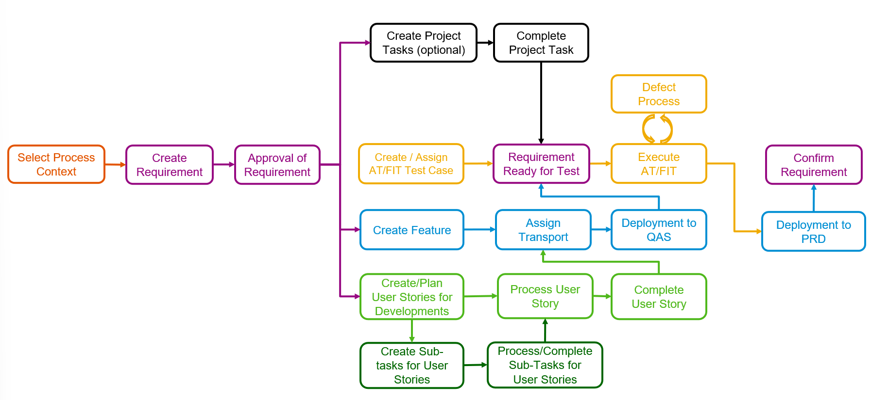Cases.

and check readiness for these 4 use cases:

# Get an overview on your implementation progress per entity

Scope, Requirement, Feature, Test Cases

# Identify Requirements that are approved and ready for implememtation

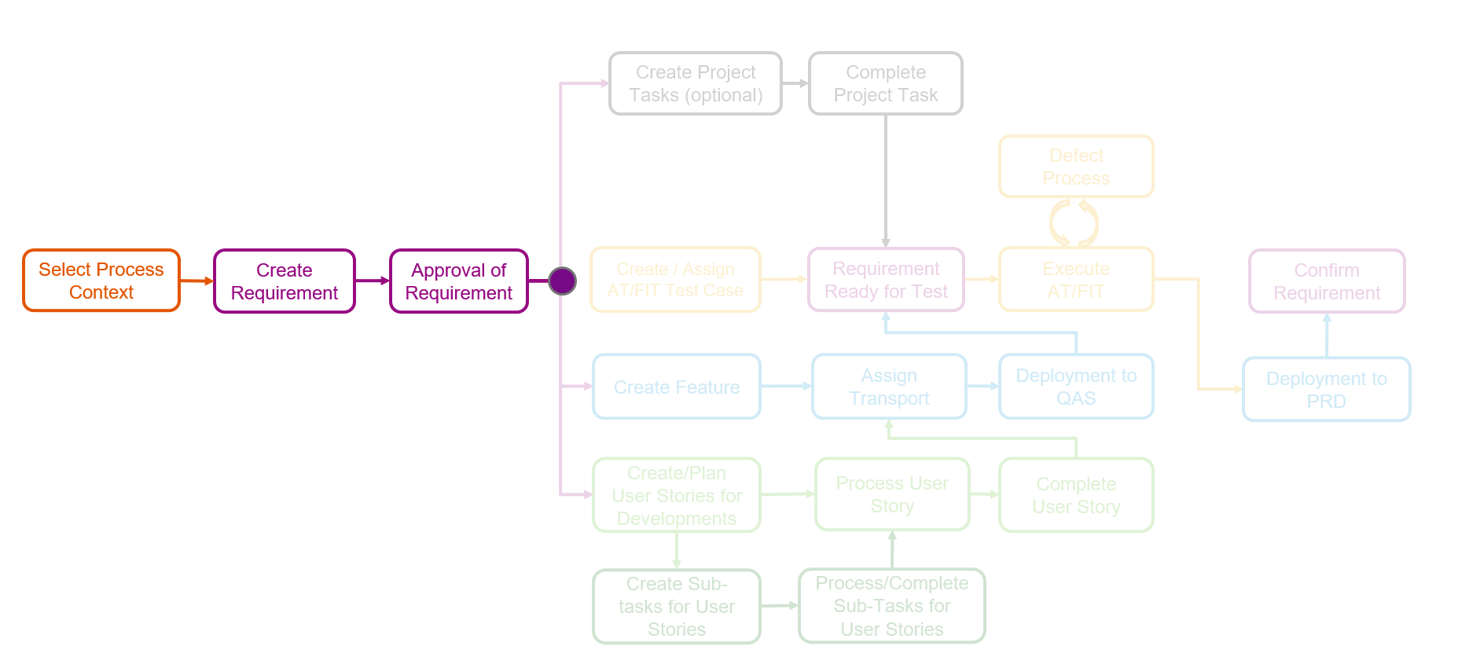

# Identify Requirements that are ready to be tested

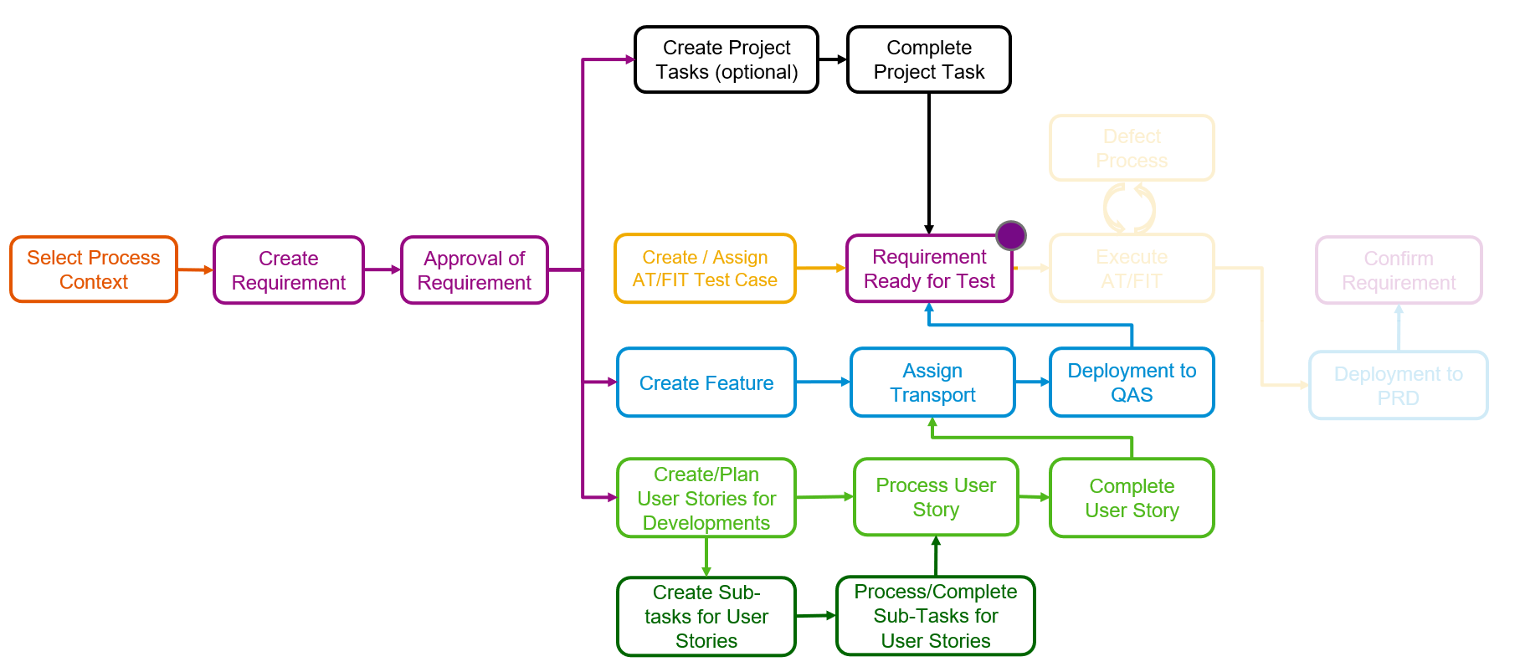

# IDENTIFY FEATURES that are ready for deplOyment

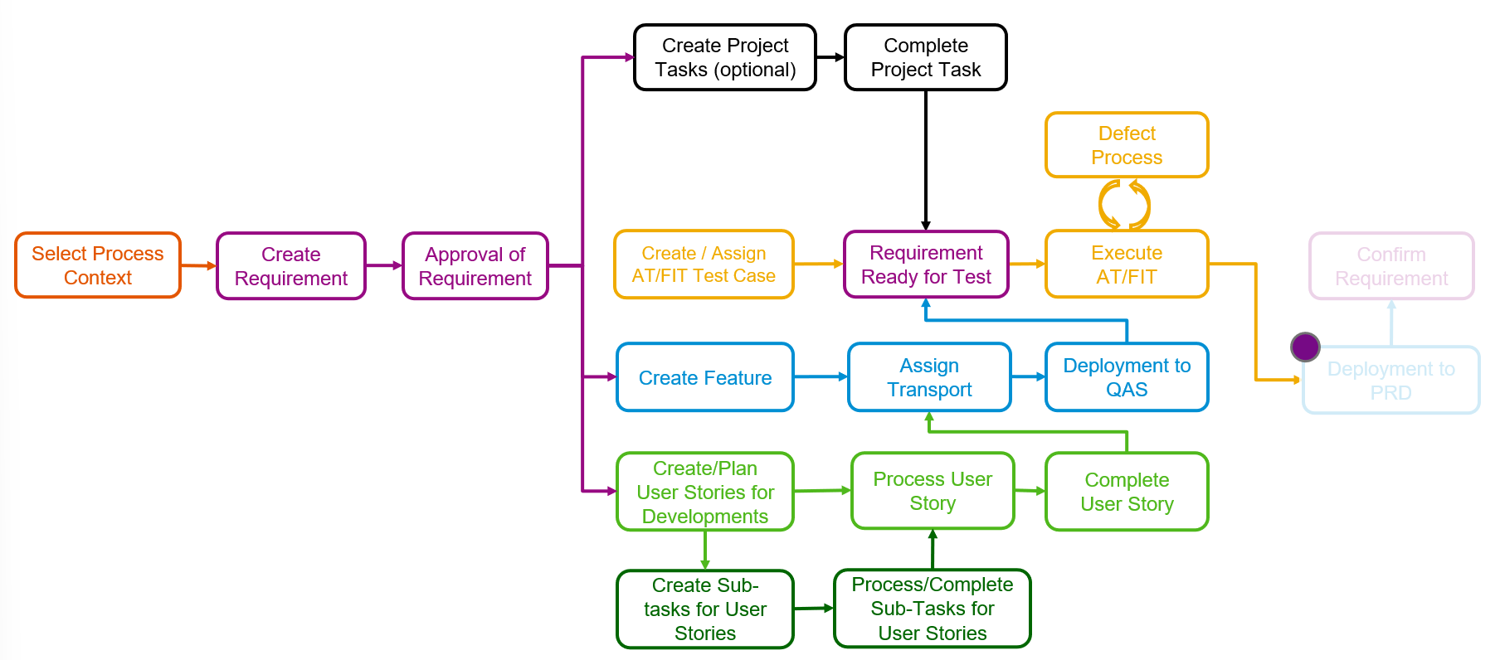

**Important Instruction:**

To avoid any side effects for the other participants working in the same tenant and project, this exercise should focus on read-only activities. Therefore, please do not change any data like status values for any existing entity in the project ‘TechEd 2022’ but feel free to create additional Requirements, User Stories, Test Cases etc. and change those.

| Explanation | Screenshot |
| --- | --- |
| **Overview** |  |
| 1. Open the Overview Page while clicking on the tile Overview in the launchpad group SAP Cloud ALM for Implementation |  |
| 1. Select Project ‘TechEd 2022’ in the filter bar and check the ‘Solution Processes per Scope’ card. Use the mouse over tooltip to get the number of processes and requirements per scope. |  |
|
| 1. Check the Requirements card regarding numbers of requirements per status and per priority |  |
| 1. Check the Requirements Distribution card regarding numbers of requirements by Scope and Status. |  |
| 1. Check the Feature card regarding number of Features by Status and Priority |  |
| 1. Check Test Case Preparation card regarding number of test cases are ‘In Preparation’ or ‘Prepared’ |  |
| 1. Check Test Execution card and Failed Manual Test Runs regarding Test Execution Status. |  |
| 1. Check Defects cards regarding number of open defects per priority |  |
| 1. In the filter bar select one of the Scope values from the drop-down list and check the number in the cards |  |
| 1. Remove any Scope values from filter bar |  |
| **Requirements ready for implementation** |  |
| 1. In the Requirements card click on the bar of status ‘In Approval’ |  |
| 1. In the filter bar for ‘Open Requirements’ field ‘Approval’ select value ‘Approved’ to get all requirements that are ready for implementation. |  |
| **Requirements ready for test** |  |
| 1. Open the Analytics Page while clicking on the Analytics button on left navigation bar:  or go back to ‘Home’ and select tile Analytics in the launchpad group SAP Cloud ALM for Implementation |  |
| 1. Select tile Requirement Traceability |  |
| 1. Use the filter to get all requirements in status ‘In Realization’ where related Feature is ‘In Implementation’ or ‘In Testing’ and **all** related User Stories are ‘Done’ and **all** related Test Cases are ‘Prepared’ and Test Execution Status is ‘Initial’ |  |
| 1. For first requirement in the list, click on the bar in column Test Execution to see all navigation options. |  |
| **Requirements ready for deployment** |  |
| 1. Delete all filter values except for Project, e.g., while selecting the default view ‘Requirement Traceability’ |  |
| 1. Use the filter to get all requirements in status ‘In Testing’ where related Feature is ‘In Implementation’ or ‘In Testing’ and **all** related User Stories are ‘Done’ and **all** related Test Cases are ‘Prepared’ and Test Execution Status is ‘Passed’ |  |
| 1. For first requirement in the list, click on the bar in column Feature to see all navigation options. |  |